reference:

Automatic extraction of relevant features from time series

<http://tsfresh.readthedocs.io>

<https://github.com/blue-yonder/tsfresh>

<https://media.readthedocs.org/pdf/tsfresh/latest/tsfresh.pdf>

#### quantile



#### skewness



#### kurtosis



#### energy



#### symmetry_looking



#### standard_deviation

##### large_standard_deviation

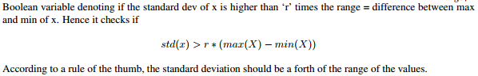

##### variance_larger_than_standard_deviation

#### duplicate

##### has_duplicate

##### has_duplicate_max

##### has_duplicate_min

#### count

##### count_above_mean

##### count_below_mean

##### range count



##### value_count



#### change

##### sum_values



##### mean change

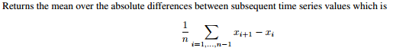

##### abs sum of change

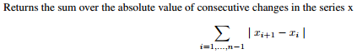

##### mean abs sum of change

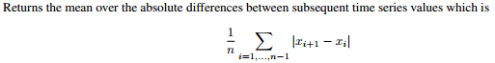

##### mean abs change quantiles





#### correlation

##### auto-correlation



##### mean_autocorrelation

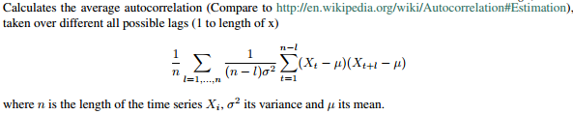

#### unit root



#### peaks

##### number_peaks



##### number_cwt_peaks



##### large_number_of_peaks



示例：

find_peaks <- function (x, m = 3){

shape <- diff(sign(diff(x, na.pad = FALSE)))

pks <- sapply(which(shape < 0), FUN = function(i){

z <- i - m + 1

z <- ifelse(z > 0, z, 1)

w <- i + m + 1

w <- ifelse(w < length(x), w, length(x))

if(all(x[c(z : i, (i + 2) : w)] <= x[i + 1])) return(i + 1) else return(numeric(0))

})

pks <- unlist(pks)

pks

}

<https://stats.stackexchange.com/questions/22974/how-to-find-local-peaks-valleys-in-a-series-of-data>